4. Evolution of Circulatory Systems: Structure and Function *Ch 44*

______________________________________________________________________________

I. Introduction *(1031)*

A. Evolution of Complexity: Body Size and Body Cavities

B. Transport Functions of Circulatory Systems

II. Structure and Function of Circulatory Systems *(1032-1034, 1042-1045)*

A. Basic Structural Units

1. Hearts

2. Arteries and arterioles

3. Venules and veins

4. Valves

5. Capillary beds

B. Capillary Function

1. hydrostatic pressure

2. osmotic pressure

C. Open *versus* Closed Circulatory Systems

D. Circulatory Circuits

1. Pulmonary

2. Systemic

III. Circulatory Systems in Invertebrates *(1032-1033)*

A. Mollusks

1. General pattern of circulation

2. Closed systems in Cephalopoda

B. Insects

1. Relation to respiratory structures

2. Vessels and blood tracing

3. Functioning of the tube heart

IV. Circulatory Systems in Vertebrates *(1033-1034)*

A. General Characteristics

B. Fishes

1. Gills and oxygen acquisition

2. Circuitry and heart structure

C. Amphibians and Reptiles

1. Lungs and oxygen acquisition

2. Circuitry and heart structure

D. Birds and Mammals

1. Circuitry

2. Heart structure

3. Functional significance

4. Analogy of systems

04-1

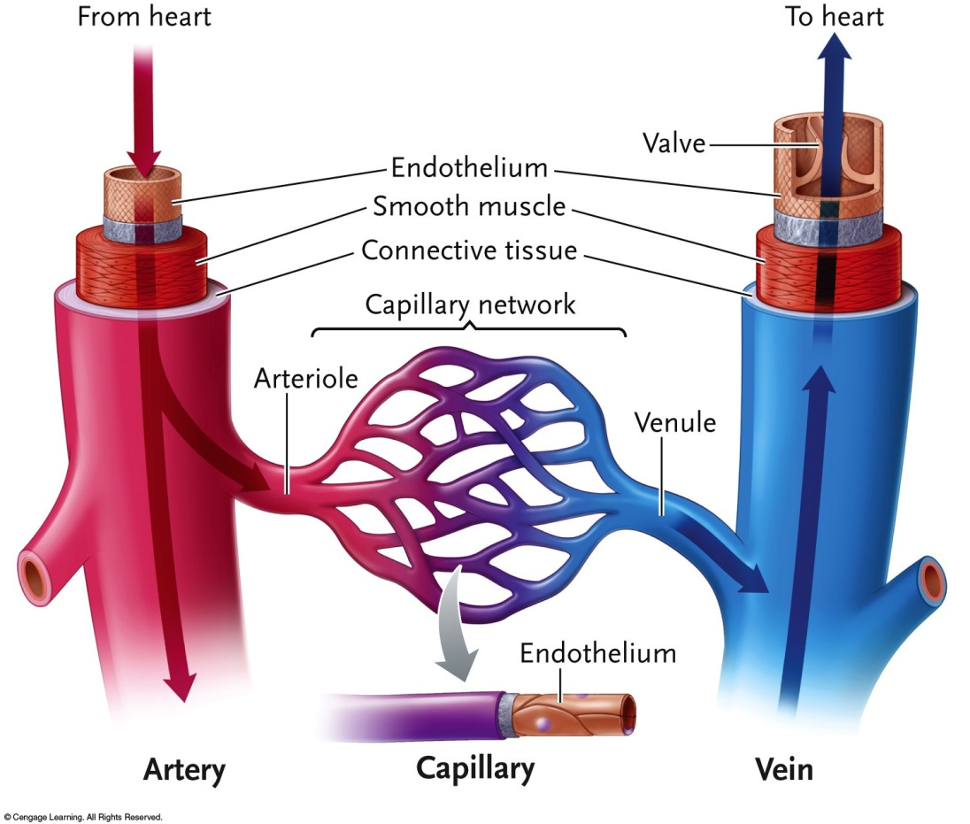

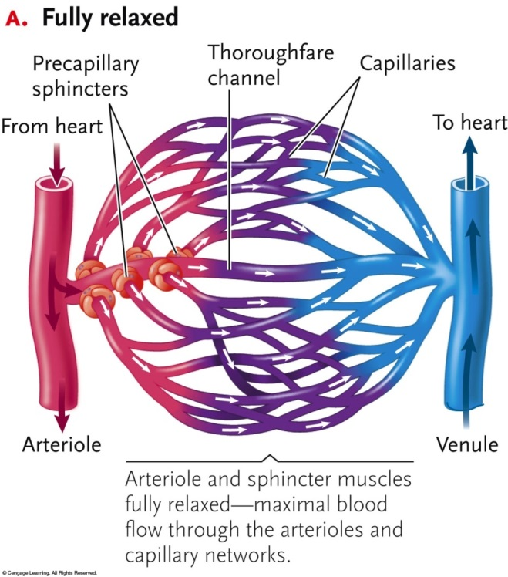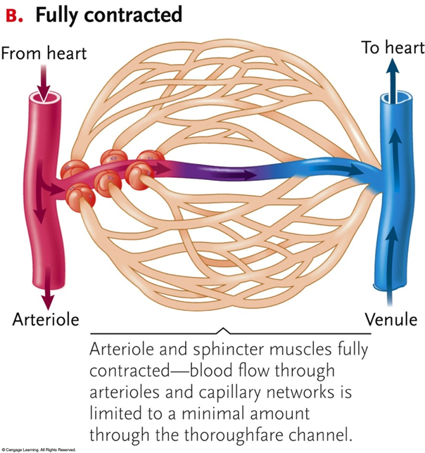

04-2

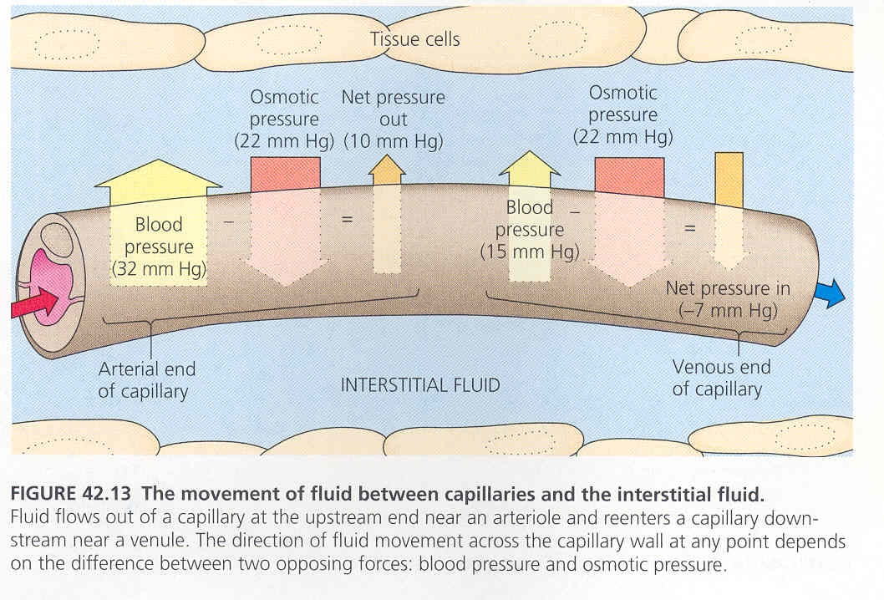

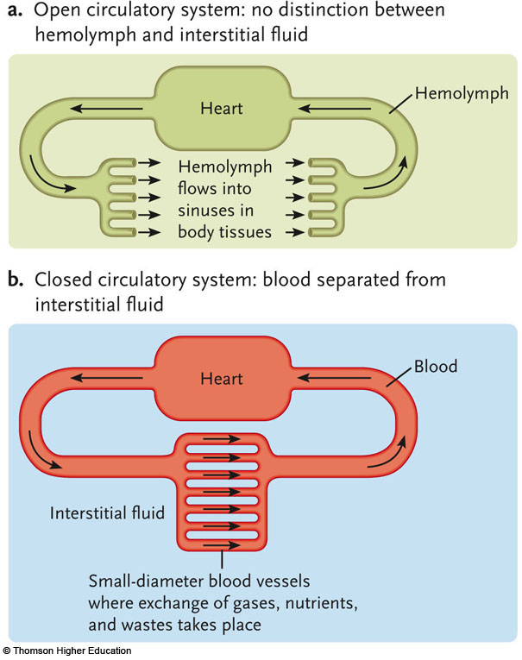

04-3

SQUID

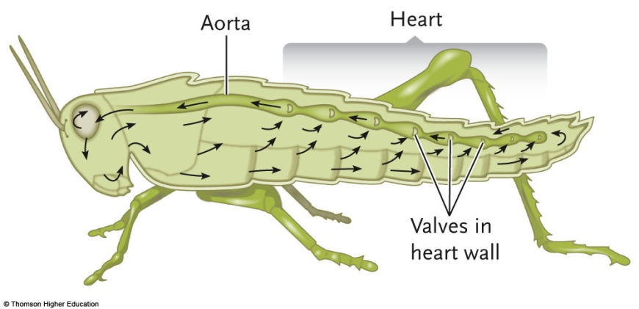 INSECT

04-4

